**ASIGNMENT**

**(DEFECT MANAGEMENT)**

#What is Bug Life Cycle?

Defect Life Cycle or Bug Life Cycle in software testing is the specific set of states that defect or bug goes through in its entire life. The purpose of Defect life cycle is to easily coordinate and communicate current status of defect which changes to various assignees and make the defect fixing process systematic and efficient.

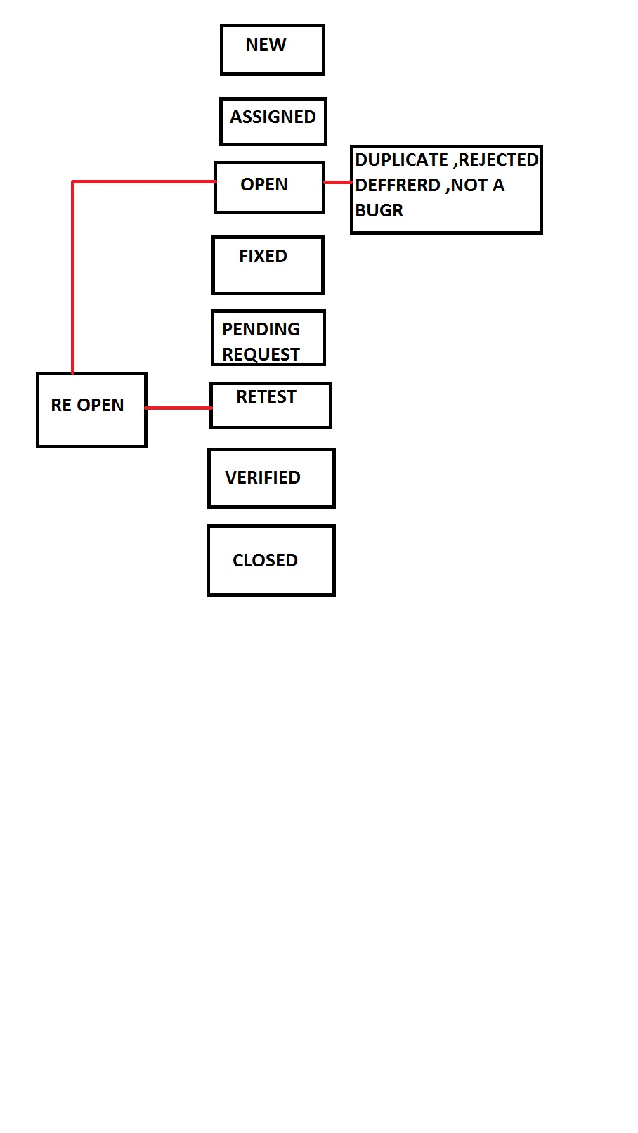

#Difference between Priority and Severity ?

* Priority is the order in which the developer should resolve a defect whereas Severity is the degree of impact that a defect has on the operation of the product.
* Priority is categorized into three types: low, medium and high whereas Severity is categorized into five types: critical, major, moderate, minor and cosmetic.
* Priority is associated with scheduling while Severity is associated with functionality or standards.
* Priority indicates how soon the bug should be fixed whereas Severity indicates the seriousness of the defect on the product functionality.
* Priority of defects is decided in consultation with the manager/client while Severity levels of the defects are determined by the QA engineer.
* Priority value is subjective and can change over a period of time depending on the change in the project situation whereas Severity value is objective and less likely to change.
* High Priority and low severity status indicates, defect have to be fixed on immediate bases but does not affect the application while High Severity and low priority status indicates defect have to be fixed but not on immediate bases.
* Priority status is based on customer requirements whereas Severity status is based on the technical aspect of the product.

#Bug categories are…?

7 Common Types of Software Bugs Every Tester Should Know

1. Bug database defect
2. Critical functionality defect
3. Functionality defect
4. Security defect
5. User interface defect

#What is priority ?

 One can define Priority as a parameter for deciding the order in which one can fix the defect. In this, the defect with a higher priority first needs to get fixed. Priority basically defines the order in which one would resolve any given defect.

#What is severity?

 define Severity as the extent to which any given defect can affect/ impact a particular software. Severity is basically a parameter that denotes the impact of any defect and its implication on a software's functionality. In other words, Severity defines the overall impact that any defect can have on a system.

#Advantage of Bugzila?

* It improves the quality of the product.
* It enhances the communication between the developing team and the testing team.
* It has the capability to adapt to multiple situations.